1. Overview:
   * What is the problem we are trying to solve?

* When traveling, attending an event, planning an outdoor activity or for daily routines/work like farming, people need an accurate up to date weather information. Unlike the era of relying on weather forecast provided by main stream media, technology has made it accessible through mobile devices. Despite this, it can be inconvenient or unreliable or complex for many.
  + Why are we doing this?
    - I will provide a simple and intuitive interface, which will enable the users to quickly access the weather information they need. I will achieve this by ensuring that I develop a user-friendly app that will give easy access to the user with current weather conditions, 10 days forecasts, suggestions on what to wear based on a weather condition and sunrise/sunset times for any desired city.

1. Who is the audience?

The audience is anyone who needs accurate weather information ranging from travelers, professionals or for personal use purposes such as wanting to know the weather for the week so that to plan your activities for the week. The app aims not to limit the users to only a specific people, but to offer information to anyone who needs it by allowing them to easily enter a city and get relevant weather forecast for the next 10 days.

1. List of the major functions of the application. What will it do? List these in as much detail as you can.

* Display Current Weather: Show the temperature, wind strength, condition such as sunny or rainy
* 10 days Forecast: Provide weather forecast for the next 10 days.
* Sunrise/Sunset: Know the times the sun rises or sets in certain cities or towns. This will be helpful to travel enthusiasts who love a sunset or sunrise photography.
* What to wear: Suggest to users the kind of clothing such as light or heavy based on weather conditions.
* Error Handling: Provide information to users if they have mistyped a city/town and offer suggestions on what the accurate city name is.
* Display Cities: Use transition to display different cities entering on the right

1. Wireframes of the major views (Mobile and desktop...do the mobile wireframes first!)

Mobile

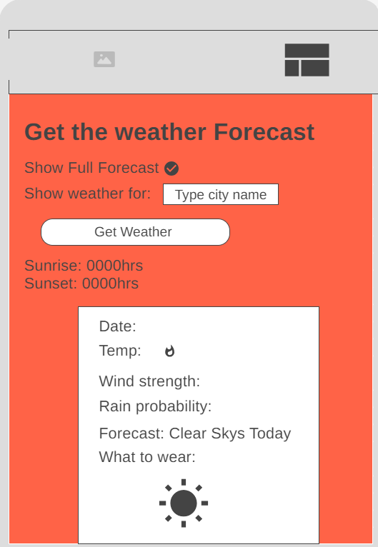

Desktop

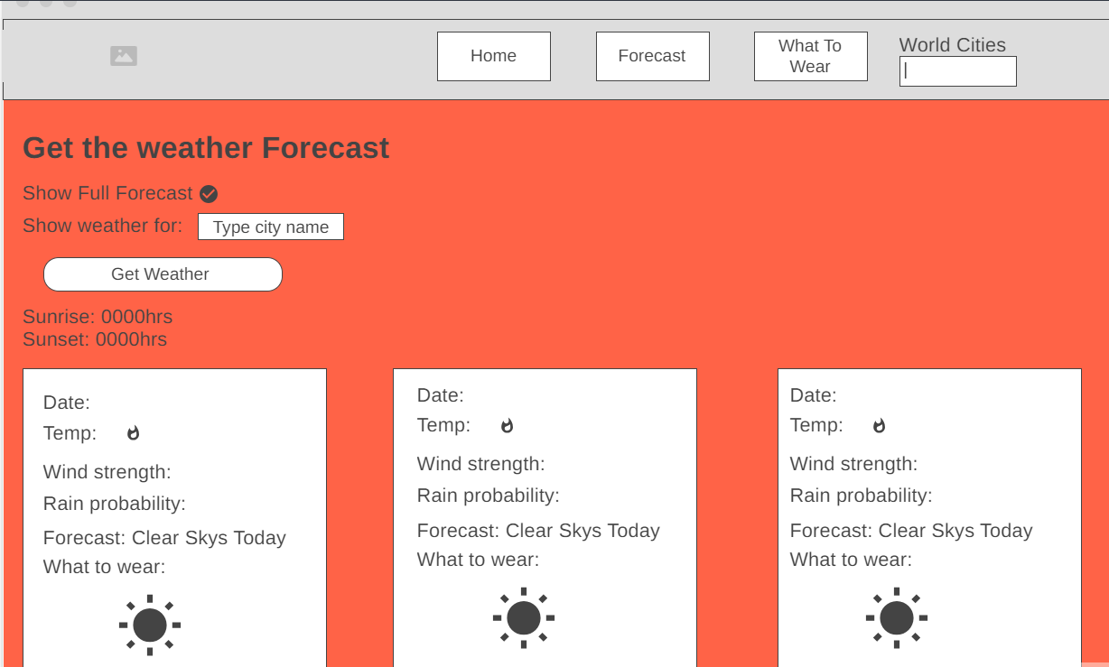

1. External API Data source(s).

* OpenWeatherMap API to retrieve current weather, 10 days forecast and sunrise/sunset data for a specified city
* City API to retrieve names of cities around the world
* Local JSON File: Show what to wear based on weather conditions. Cache frequently accessed data for greater performance.

1. Initial Module list

* HTML/CSS - User interface components (frontend)
* Current Weather, 10 days Forecast and Sunrise/Sunset Times Modules.
* JavaScript - Weather Data Retrieval
* Module for error handling

1. Colors/Typography/specific element styling

Color Palette - <https://coolors.co/0a64ec-ffffff-f50579-c9cdcf-ee1e1e>

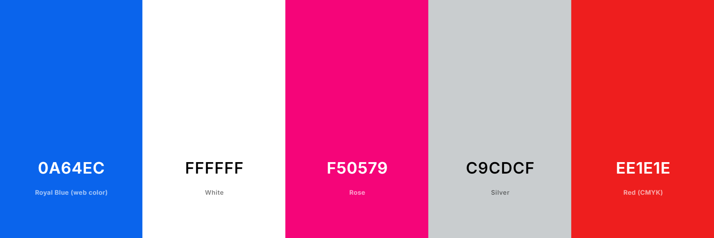

Typography

**Headlines** – font-family: "Montserrat", sans-serif;

<style>

@import url('https://fonts.googleapis.com/css2?family=Edu+AU+VIC+WA+NT+Dots:wght@400..700&family=Montserrat:ital,wght@0,100..900;1,100..900&display=swap');

</style>

**Body** – font-family: "Lato", sans-serif;

<style>

@import url('https://fonts.googleapis.com/css2?family=Edu+AU+VIC+WA+NT+Dots:wght@400..700&family=Lato:ital,wght@0,100;0,300;0,400;0,700;0,900;1,100;1,300;1,400;1,700;1,900&family=Montserrat:ital,wght@0,100..900;1,100..900&display=swap');

</style>

**Display Cities**: font-family: "Edu AU VIC WA NT Dots", cursive;

<style>

@import url('https://fonts.googleapis.com/css2?family=Edu+AU+VIC+WA+NT+Dots:wght@400..700&display=swap');

</style>

Element Styling

* Clear and easy to navigate layout

1. Schedule to provide yourself mile markers along the way to help you stay on target.

|  |  |
| --- | --- |
| Week | To Do, Create Trello |
| Week 4 | Develop the project write up |
| Week 5 | * Develop U.I using JavaScript, CSS and HTML * Create Functions and Methods * Create Local JSON file for user what to wear suggestions * Update Trello |
| Week 6 | * Linting * Use cases testing * Debug for any syntax bugs * Move Tasks to Done in Trello * Turn in project files (Github repo and Netlify link to active app) |
| Week 7 | * Work on any changes/updates |

1. Link to a Trello board with all the tasks you can think of at this point defined as cards. Again be as detailed as possible here.

<https://trello.com/invite/b/67066400ab2c7121475f1b86/ATTIf209cc50131db12f132f6899c2c3c8d605F216A7/final-project-wdd-330>